ServiceNow Development
Project Documentation format
Date | 1 October 2026
Team ID | SWTID-2026-5148
Project Name | Implement Client Script & UI Policy (Incident)
Team Size | 4

1. Introduction
• Project Title: Implement Client Script & UI Policy (Incident)
• Team Members:
o Mathangi S – Team Leader – coordination, UI Policy configuration (High Impact Control) and review
o Meena Varshini T P – Team Member – Urgency read-only action, reverse behaviour and caller scenario
o Mirthika R – Team Member – Client Scripts (onChange, onSubmit, onCellEdit)
o Muthu Priya U – Team Member – testing, State update and test documentation
2. Project Overview
• Purpose: To demonstrate how ServiceNow client-side controls (UI Policies and Client Scripts) can enforce data integrity on Incident records, so that incidents are created with complete and valid information, improving data quality, SLA compliance and service quality.
• Features:
o UI Policy "High Impact Control": when Impact = 1 – High, Assignment group becomes mandatory (Reverse if false enabled).
o UI Policy Action: Urgency becomes read-only when Impact is High.
o onChange Client Script: automatically sets Urgency to High and shows an information message when Impact is changed to High.
o onSubmit Client Script: blocks saving a High-impact Incident when Assigned To is empty and shows an error on the field.
o onCellEdit Client Script: blocks changes to the State field made directly from the list view.
3. Architecture
• Frontend: The ServiceNow Incident form and list view displayed in the browser. The UI Policy and the three Client Scripts run in the browser (client tier) using the GlideForm (g_form) API; no separate frontend framework is used.
• Backend: The ServiceNow platform (application server) delivers the form and saves records. No custom server-side code, Node.js or Express.js is used in this project.
• Database: The platform's Incident table (incident). Fields used: Impact, Urgency, Assignment group, Assigned To and State. Valid records are saved to the table after the client-side checks pass.
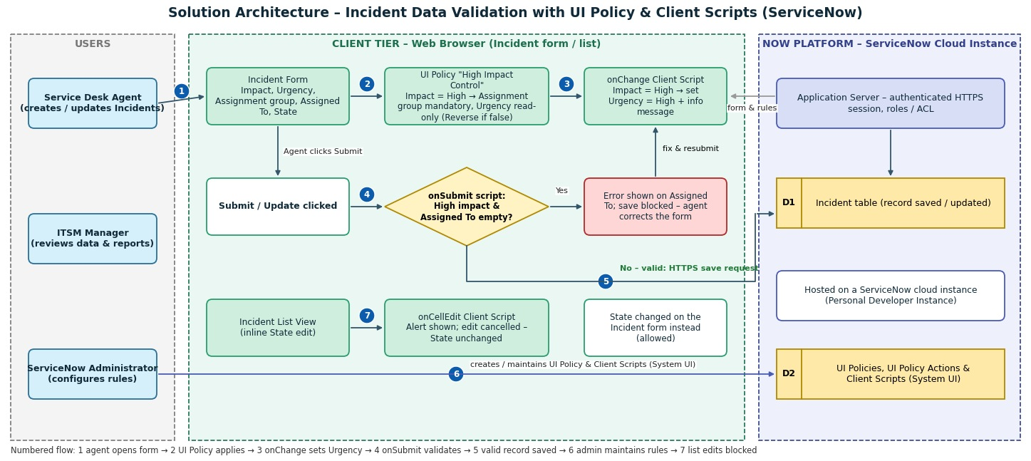
Figure 1: Solution architecture
4. Setup Instructions
• Prerequisites: A ServiceNow Personal Developer Instance (or any ServiceNow instance) and a user with administrative / configuration access; a web browser such as Google Chrome.
• Installation: No software installation or cloning is needed. Set up the configuration as follows:
o Step 1: Log in to the ServiceNow instance with administrative access.
o Step 2: Go to System UI → UI Policies → New. Create "High Impact Control" on the Incident table (Active = true, condition Impact is 1 – High, Reverse if false = true) and submit.
o Step 3: In the UI Policy Actions related list, make Assignment group mandatory and create an action for Urgency with Read-only = true.
o Step 4: Go to System UI → Client Scripts → New. Create the onChange script "Auto set urgency for high impact" (Table: Incident, Field name: Impact).
o Step 5: Create the onSubmit script "Prevent save if Assigned To missing" (Table: Incident).
o Step 6: Create the onCellEdit script "Prevent state change via list edit" (Table: Incident, Field name: State).
5. Folder Structure
• Client: Client-side configuration records in the instance: System UI → UI Policies → "High Impact Control" (with UI Policy Actions), and System UI → Client Scripts → "Auto set urgency for high impact" (onChange), "Prevent save if Assigned To missing" (onSubmit) and "Prevent state change via list edit" (onCellEdit).
• Server: No custom server-side scripts. The Incident table and application server are provided by the ServiceNow platform.
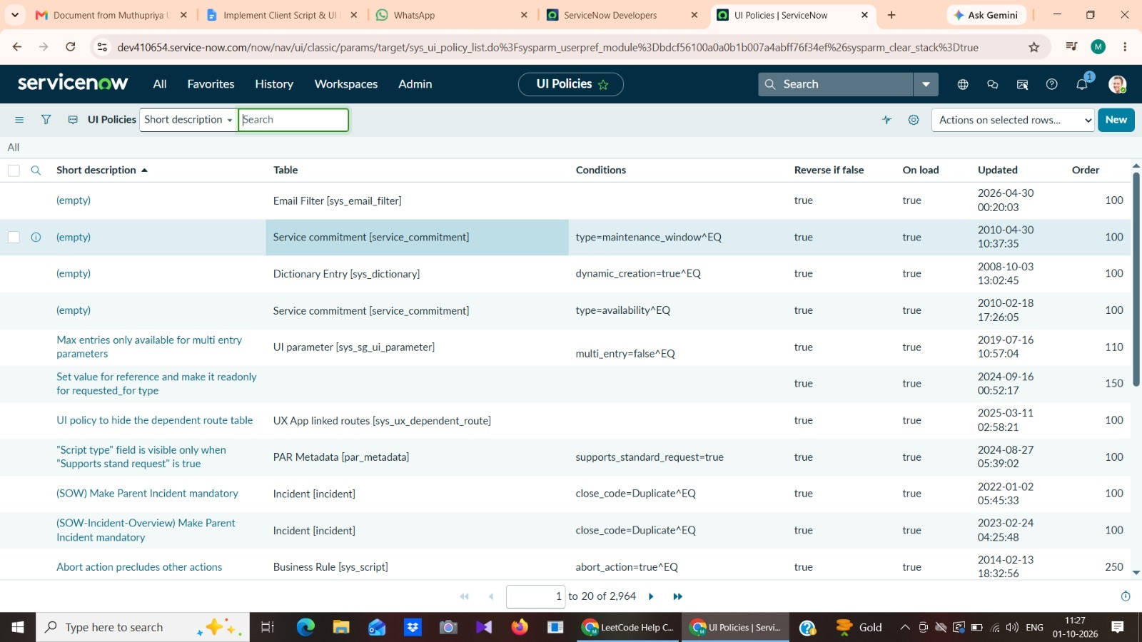
Figure 2: UI Policies list in the instance (System UI → UI Policies)
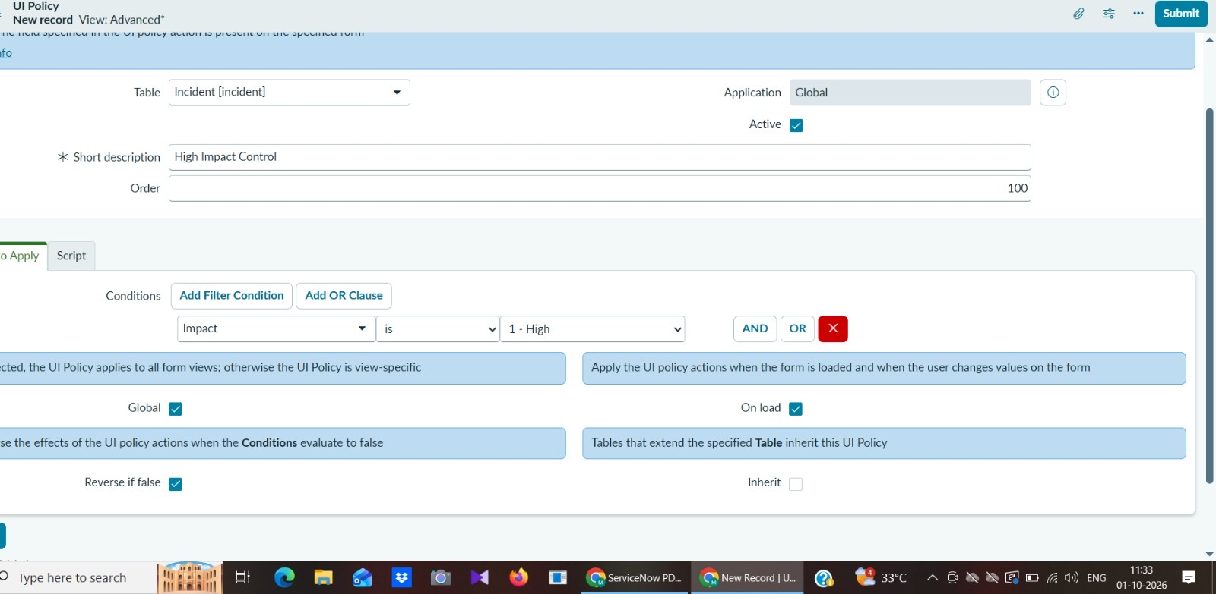
Figure 2a: UI Policy "High Impact Control" – condition Impact is 1 – High, Reverse if false
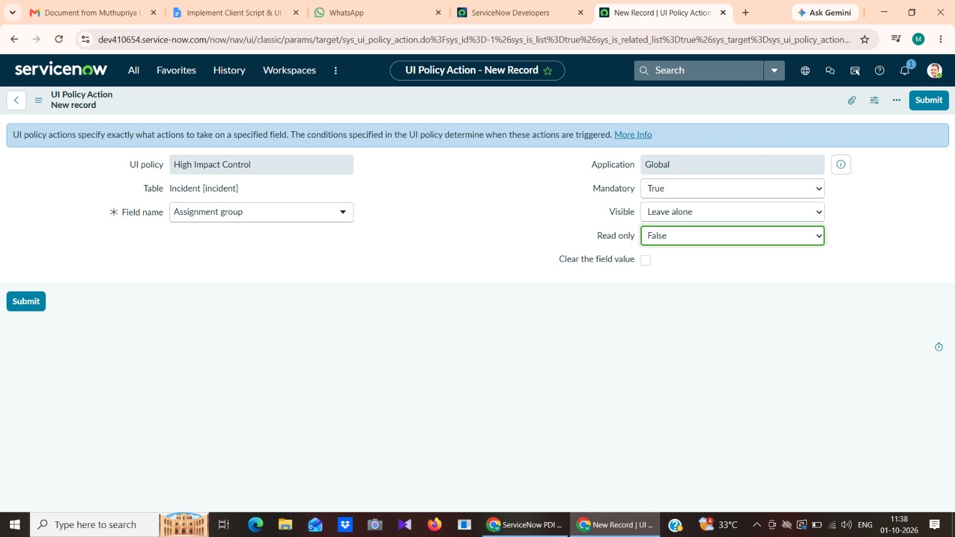
Figure 2b: UI Policy Action – Assignment group mandatory
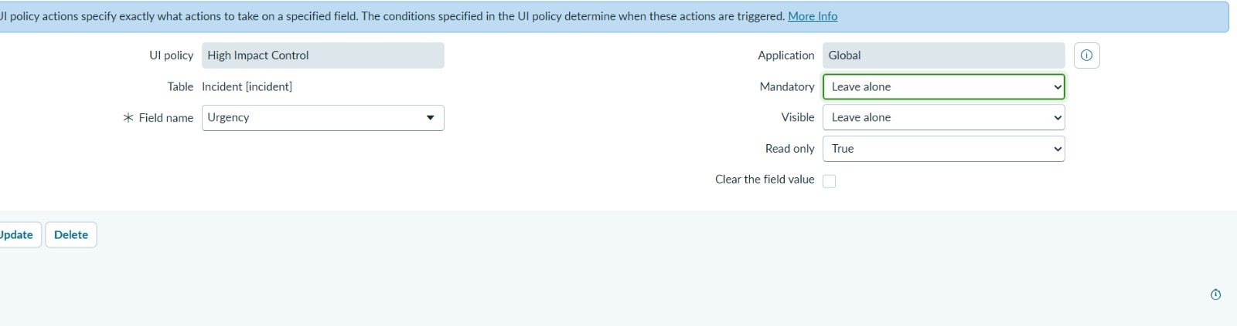
Figure 2c: UI Policy Action – Urgency read-only
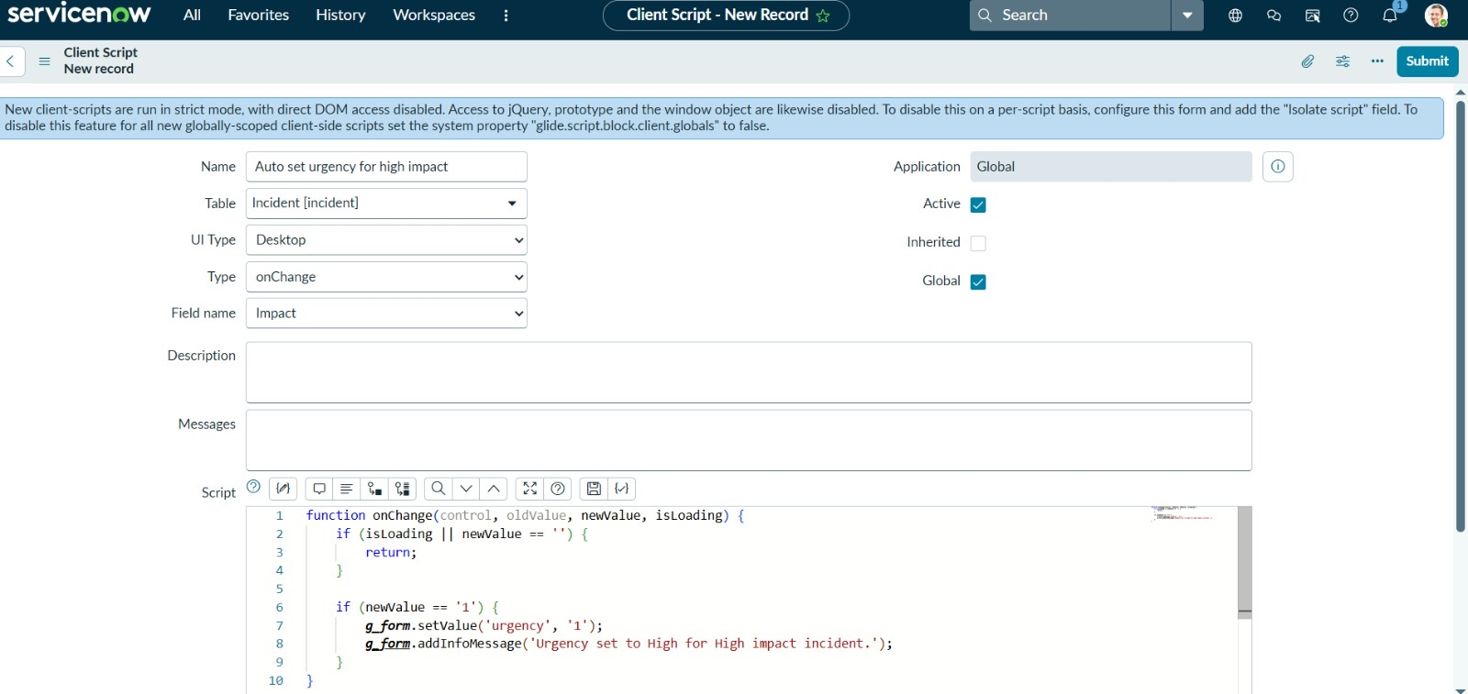
Figure 2d: onChange Client Script – Auto set urgency for high impact
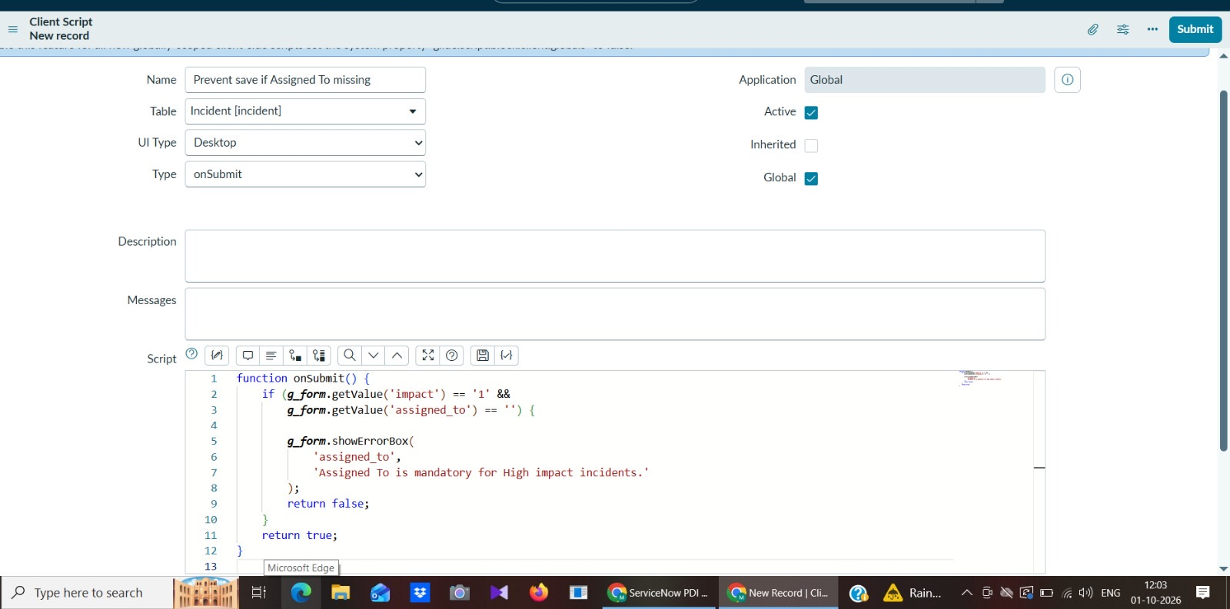
Figure 2e: onSubmit Client Script – Prevent save if Assigned To missing
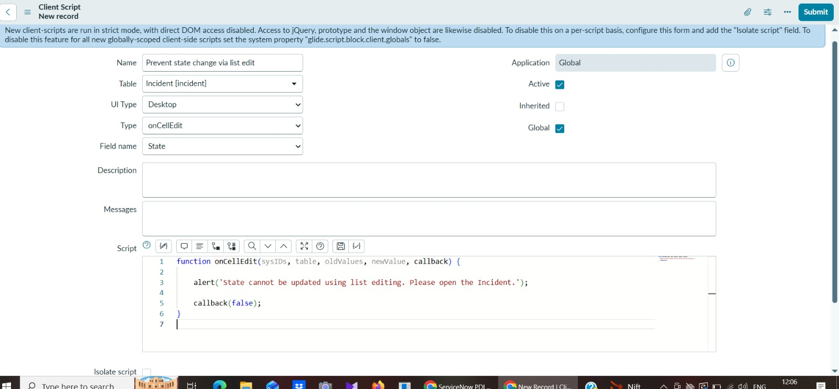
Figure 2f: onCellEdit Client Script – Prevent state change via list edit
6. Running the Application
• Provide commands to start the frontend and backend servers locally. No npm commands are required; the application runs inside the ServiceNow instance.
o Frontend: log in to the instance and open Incident → Create New (form) or Incident → All (list view).
o Backend: nothing to start; the ServiceNow platform runs the instance and saves the records.
7. API Documentation
• No custom REST endpoints are exposed. The solution uses the client-side GlideForm API available in Client Scripts:
API / Method | Parameters | Used in | Example
g_form.getValue(fieldName) | field name | onSubmit | g_form.getValue('impact') returns '1' for High
g_form.setValue(fieldName, value) | field name, value | onChange | g_form.setValue('urgency', '1')
g_form.addInfoMessage(message) | message text | onChange | Shows "Urgency set to High for High impact incident."
g_form.showErrorBox(fieldName, message) | field name, message | onSubmit | Shows "Assigned To is mandatory for High impact incidents."
callback(false) | boolean | onCellEdit | Cancels the list edit of State

8. Authentication
• Authentication and authorization are handled by the ServiceNow platform. Users log in with their instance credentials and a platform session is maintained by ServiceNow; no custom tokens are implemented in this project.
• Role-based access applies: configuring UI Policies and Client Scripts requires administrative access, while incident users (for example ITIL users) create and update Incidents and are subject to the rules.
9. User Interface
• Screenshots of the UI Policy, the three Client Scripts and the list-edit alert are given in Figures 2 to 2f and Figure 6.
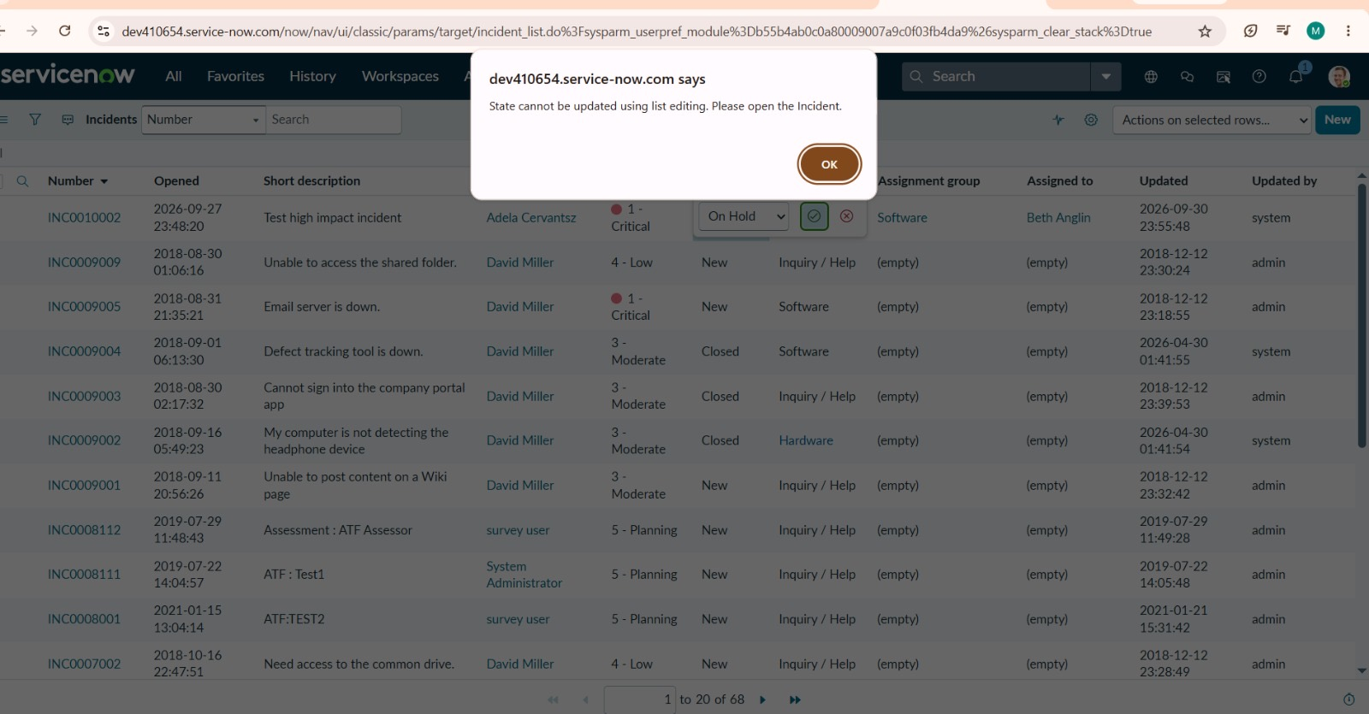
Figure 6: List-view edit of State blocked
10. Testing
• Describe the testing strategy and tools used.
o Functional testing: nine test cases (FT-01 to FT-09) covering the UI Policy, the three Client Scripts, the reverse condition and form-based State updates.
o Performance testing: five test cases (PT-01 to PT-05) on client-side response time, save-validation time, form load time, list view with many records and multi-user use.
o User acceptance testing: twelve test cases (TC-001 to TC-012) including negative scenarios.
o Tools: ServiceNow instance with Incident form and list, and the browser developer tools for timing.
11. Screenshots or Demo
• The screenshots in Figures 2 to 2f and Figure 6 show the application. A demo video link can be added in the appendix.
• Demo link: [add your demo link here]
12. Known Issues
• Document any known bugs or issues that users or developers should be aware of.
o Urgency stays at High after Impact is changed from High to Medium because the onChange script only handles Impact = High.
o The UI Policy makes Assignment group mandatory, while the onSubmit script checks Assigned To, so users see two different rules.
o The onCellEdit script uses a browser alert() pop-up instead of an on-form message.
o Client-side checks do not replace server-side enforcement (for example imports or API updates are not covered).
13. Future Enhancements
• Outline potential future features or improvements that could be made to the project.
o Add a server-side Data Policy or Business Rule as a backup to the client-side checks.
o Reset Urgency when Impact is lowered, and show all missing-field errors in one message.
o Replace the alert() pop-up with an on-form message.
o Add an ACL or bulk-update guard on the State field and a manager notification for High-impact incidents.
o Extend the same pattern to other tables such as Problem and Change, and add a dashboard for High-impact data quality.

